Newsletter October 2021 Issue 7

1. Editorial news - Trudy Ryall, dbvtrudy@gmail.com
Hello I hope that everyone has been able to get out into the community more now that the lockdown restrictions have lifted in Victoria and the weather is getting warmer. We are excited to meet you all in person again – you’re welcome to drop in for a visit on Wednesdays or Thursdays, and don’t forget the DBV Christmas party on 1st Dec in the park. The newsletter is longer this time – five pages. There is a recipe, craft stories, deafblind tips and other news for the Deafblind community. Enjoy reading!

2. Jo Porter’s recipe - Hearty vegetable soup
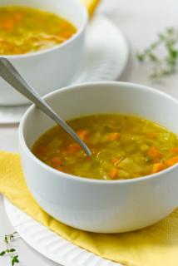
- Buy the ingredients: 4 rashers of bacon, 1 cup of rice, 1 large onion, 2 cloves of garlic, 4 carrots, 3 celery sticks, 3 zucchinis, and 1 can of chopped tomato, 1 litre of vegetable stock.
- Cut up all ingredients diced small.
- Add oil and stir/fry in pot onion, garlic & bacon (5 minutes.)
- Add carrots, celery, zucchinis and stir/fry in pot until all soft (10 minutes.)
- Add rice and stir (3 minutes)
- Add can of tomato, vegetable stock and add more water if it is too thick.
- Let it boil on low heat simmer for 2 hours.
- And serve your soup in a bowl.
Jo’s hearty vegetable soup

3. An art and craft story – Kathy Wise
I was excited about the yarn bombing event for DeafBlind Awareness week 2021 and was motivated to join in. I always love to help and chat with the friendly Deafblind community. I really love crocheting. I learnt how at special school for the deaf. I also like card making, sewing pictures on plastic canvas, printing pretty pictures, laminating then cutting to hang in pictures like Christmas decorations. I love keeping busy and keep my mind off from other things!
I learnt different arts and craft from Emily at Able Australia and from my local craft group at Coatesville Uniting church in East Bentleigh. I go there every Monday morning (when no Covid lockdown). My dream is one day I would love to have my own little market to sell my craft things or community markets or maybe in the future why not Deafblind Victoria can have its own little stalls to sell lovely and interesting art and crafts that Deafblind people made! I know few Deafblind people love making nice and interesting crafts.
How to make fridge magnets: I do have laminator at home my brainwave is looking for any nice pictures like owls or your favourite AFL footy teams or any pictures you find, any shapes with A4 laminator pouch put picture into the pouch then laminating it until it cools down cut around the pictures then put double tape on the magnet then stick back of the pictures. I would like to teach DBV members at arts and crafts group.

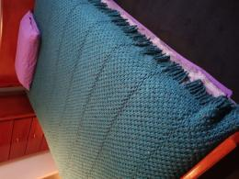
4. Art helps Gina’s mental health during Covid time - Gina Pontelandlfo
Gina Pontelandolfo has Usher Syndrome. She was born deaf and is gradually going blind over time. Gina is well known as crafty! Gina has been a creative person all her life from making clothes, art and crafts. She started macramé at 23 and let it go for a while. It was only recently she embraced it again as a hobby, and it grew into something else, like teaching deaf people. Macramé is a very hands-on tactile craft. It gave Gina a sense of self; something she had control and feel for. During lockdown she gave herself a challenge: make a queen-size blanket. It was born from 18 big balls of wool and 8 weeks in the making. It gave Gina a purpose and a reason to get through lockdown. It was very meditative and helped her with her mental health and wellbeing.
5. DBV Recreation – Alex Sar - dbvalexs@gmail.com
Gina's macramé blanket

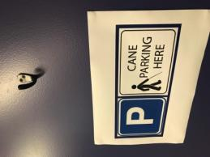
Hi Deafblind Victoria members, I hope you're all coping well, the sun is shining and flowers are blooming, and lockdown has ended (Woo hoo!). I just want to let you know Deafblind Victoria will be running Recreation activities and we would like to have your ideas of activities. This is a great opportunity for you to be included. Please email me with your activity. Thank you in advance and I look forward hearing from you with your ideas.

6. Volunteering at DBV - Robert Lokmer
Robert has been working hard at DBV as a volunteer. He put up pictures photos taken by Jessica a photographer - frames of deafblind people in DBV office. He put hooks at the entrance for coats and white canes, and he donated a monitor stand. Next time when you visit DBV have a look. Thank you, Robert, for your volunteering and donations! DBV welcomes Deafblind volunteers. To get involved, email Alex: dbvalexs@gmail.com
7. Products that help deafblind people - Andrew Howard
Coat hook at DBV for cane parking
Andrew gives ideas about adaptive technologies that help deafblind people in their environments:
- Hot water dispenser to make a drink
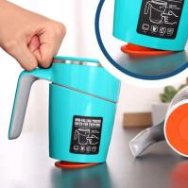
- Audio level liquid vibrating gadget to make a drink
- Anti-spill suction mug to not spill your drink
- IPhone alarm timer vibrates for cooking
- Big bold tactile timer for cooking
- Non slip table mat and coaster
- Non slip food preparation
- Water boil alert.
Vision Australia has a store to book an appointment and have a look at products: Julie.Scott@visionaustralia.org
Anti-spill suction mug

8. DBV member profile - Andrew Howard
I grew up on a farm when I was a little boy in Leonards Hill near Daylesford. The family farming has a lot of history. My grandpa had a potato farm. I used to help with the potato to farming processes. I also used to make potato chips too and pack them in bags for shops to sell them. There are other things I help with dad is the cow farming for beef cattle meat. And chopping wood and out in bags for local community members to buy for their wood fires. One day I hope show deafblind community look around Daylesford and see the local shops and go to cafes for lunch and go for a walk around Daylesford Lake and there is mineral springs to get water out of it.

9. Deafblind tips: Hospital communication - Heather Lawson, dbvheather@gmail.com
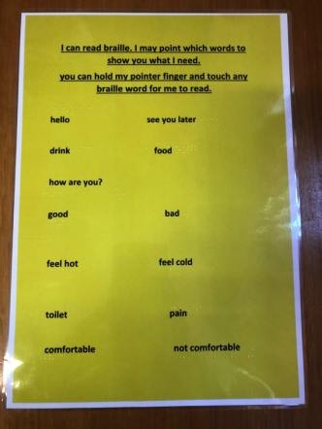
Before my surgery this year I had an idea to create a better communication process between me and nurses at the hospital. Sometimes there are no interpreters or comm-guides available to support the deafblind person. I typed up short instructions with words and braille and then laminated it in size A4 paper. See photo of my original template. It said “I can read braille. I may point which words to show you what I need. You can hold my pointer finger and touch any braille word for me to read.” The words under the instruction are: “hello, drink, see you later, food, how are you, good, bad, feel hot, feel cold, toilet, pain, comfortable, not comfortable.”
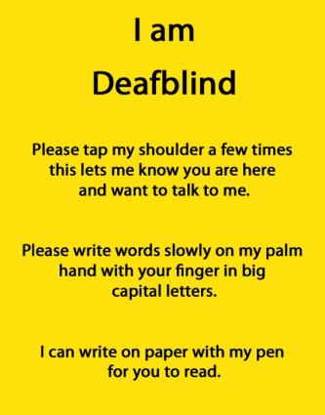
See another photo of a bright yellow sign. This yellow with large black print sign is to pin on the wall near the hospital bed for better attention because most in the wards the walls are white. Something for a contrast to be easily seen. The yellow sign on the top of A4 paper in big block and bold saying 'I AM DEAFBLIND' The next lines says, “Please tap my shoulder few times this lets me know you are here and want to talk to me. Please write words slowly on my palm hand with your finger in big capital letters. I can write on paper with my pen for you to read.”
From my experiences, I enjoyed communicate with friendly nurses which made me feel good. Also I had the notebook with a pen for some specific information. I write notes for them to read. I remember after my surgery in the recovery room a nurse woke me up. I was drowsy while nurse held my finger to the braille word. 'How are you' I read and signed "thumb up'. After our short conversation, I was surprised that a nurse hugged me. Something that she was proud to talk to me herself. I received a few feedbacks from nurses; they liked the idea of communication template. They suggested me to add some more words. I will improve this system but it is really up to deafblind persons to create to meet their own
communication needs.

10. 11th National Deafblind Conference, (29th June until 1st July 2022)
Theme: “DeafBlind keeping connected through COVID and beyond.” Pre-Conference Wednesday 29th June, main Conference Thursday 30th of June to Friday 1st of July. Esplanade Hotel by Rydges, Corner Marine Terrace and Essex St, Fremantle, 6160 Western Australia. If you are interested see website www.ausdbconf2022.com.au and contact email: karen.wickham@senses.org.au

11. Mental Health Grant - Trudy Ryall, dbvtrudy@gmail.com
DBV and Trudy Ryall successfully applied for grant for a mental health project. In 2022 DBV will be running a Mental Health Forum for Deafblind people. Keep an eye out for that. The grant comes from a trust fund named in honour of Ben Souter, a well-known interpreter who died in 2018. Ben was passionate about Deaf mental health. He felt strongly that deaf people, especially Auslan users, should have better access to mental health information and services.
12. David Blyth Award – Claire Tellefson
The David Blyth award is given by Blind Citizens Australia every two years to recognise people who improve the lives of blind and vision impaired Australians. This year on International White Cane Day, October 15, the award was given to Claire Tellefson. Many DBV members know Claire for setting up and running Ablelink at Ross House. She supported deafblind people learning braille and technology, and encouraged deafblind people to share their skills with each other. DBV is proud to continue her legacy at Ross House with deafblind peer support and training. Congratulations Claire!

13. DBV Christmas party in Park - deafblindadvocacy@gmail.com
When: 1st December Wednesday 2021
Changes: If there are any changes DBV will let you know example bad weather or Covid rules changes
Where: Behind the rowing boat sheds Alexander gardens. Moomba is usually in the same place.
Meet: Under the clocks at Flinders St Station 11 am to walk over the park.
Time: From 12 pm until 4 pm.
Near: train - Flinders Street Station near the bridge, go down the stairs.
Bring: your own food and drinks, rugs, (chairs) and support workers.
Note: South bank cafes are nearby to buy lunch and it is hard to find car parking – best to come by train.
Provided: Auslan interpreters, sunscreen and cold water.
RSVP: Please confirm by emailing you are coming! deafblindadvocacy@gmail.com

14. DBV updates - Website & Facebook
You can join DBV and read updated information on DBV website and Facebook page.
Website: www.deafblindvictoria.com
DBV Facebook group: www.facebook.com/dbv2018

15. Next newsletter - Articles are due Monday 14th February 2022
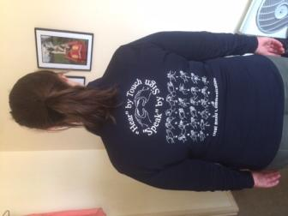
Anyone and DBV members who wish to join the DBV email list or which to send stories to the newsletters which is 5 times a year, end of the months of Feb, April, June, Aug, Oct. You can email your article (200 WORD LIMIT) and your name and email address to: deafblindadvocacy@gmail.com
17. DBV T-shirts for sale
DBV has t-shirts for sale. Wonderful gifts for Christmas time. T-shirts Short sleeved are $20. Long sleaved are $35 and different sizes available. Please request for more information and order your t-shirts from Heather Lawson email dbvfinance@gmail.com
DBV long sleeve polo shirt - back

18. Christmas holiday and celebration wishes
Deafblind Victoria will be closed over December 2021 and January 2022 holidays. You can visit on Wednesdays and Thursdays in November, or from February 1st next year. Keep in touch - Lots happening in 2023! raft group, deafblind café, recreation program, Deafblind World workshops, and DBV Connect. On behalf of DeafBlind Victoria Team and communities, we wish you all a Merry Christmas and Happy New Year! With much love from Alex, Jasper, Heather, Michelle, Ntennis, Juz, Paola and Trudy.

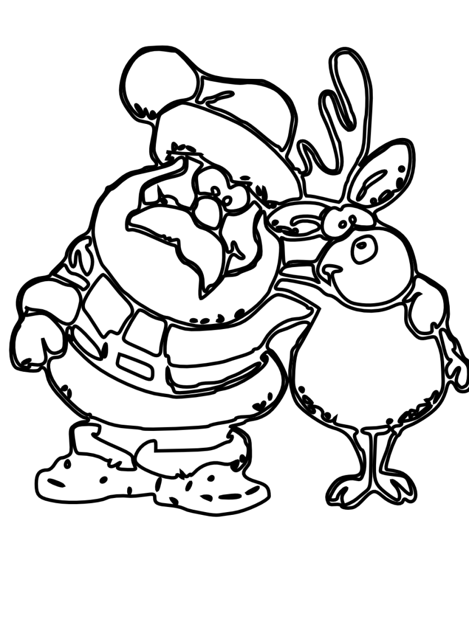
Picture Father Christmas hugging a reindeer

